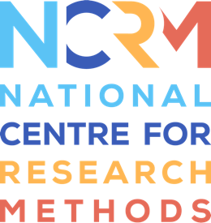
Storytelling Toolkit

Activity 4 – Something shared

Activity Four - Something shared - is a little bit different to some of the others in that we're not being quite as open as we were with those. This is where we're focusing in on a particular topic. And so while there's still an openness in that people can share what the stories or thoughts they want. And we're not just looking at how do people respond to objects in general.
And so of course, you'll choose objects that are going to be evocative, and a way to get people to tell stories. But you might find in common, you know, even in previous things, you might find that because you've chosen evocative objects, everyone talks about childhood, but it's much more focused in this one here. So it's a chance really to think about what would benefit your group in particular? So are there particular themes that would really work well with that group? Or what you're trying to do?
For example, are you trying to bring people together? Is it a new group that you'd like to start to build relations? Or is it an old established group that you think that basis of trust would lend itself to a certain topic, so you can really think about the needs of your group. And also, if you've got a specific aim or something that you want to address with that group, then this is a great idea, because you're focusing in and you're tailoring it to your group. And so you could choose one theme you could choose, your group could choose a theme as another idea here. So it could be quite general, like being a teenager, growing up, adulthood, or Christmas, for example. But it also could be a kind of object like childhood toys, or old tech, for example. You know, it really is up to you to choose, but I think it's a real chance to develop some kind of depth here. And you can get the actual activity going with a story of your own. That's a really good way to start it.
So let's say you choose old tech, bring in some of your own old tech and talk about it. And I think then you can get everyone else to share, or it's just a chance to discuss their own stories. And I think what's important here is that you can play around with it around what do you think works with your group and I think this is one that you've got an established group, it really is one for everyone to enjoy. And also, you know, members of your group can really have some quite focused input in kind of what you're trying to get out of it.

National Centre for Research Methods (NCRM)
Social Sciences
Murray Building (Bldg 58)
University of Southampton
Southampton SO17 1BJ
United Kingdom
Web www.ncrm.ac.uk
Email info@ncrm.ac.uk
Tel +44 23 8059 4539
Twitter @NCRMUK

